1. **Explain analyses and interpret results:**

I created a table of 348 New Mexico zip codes enriched with my project variables: Hispanic female population aged 15–44, their percent of the total population, and cosmetics/skincare spending per household. Then, I used external U.S. government data to link each zip code to its corresponding county name and FIPS code. I joined the two tables to fully describe each New Mexico zip code, including its city (PO_NAME), county name, and county FIPS ID (County_FIPS).

Each row/record in the table represents one zip code and includes both demographic and spending data, which allows me to identify high-opportunity neighborhoods where Hispanic women aged 15–44 are both concentrated and likely to spend more on cosmetics and skincare, supporting my outreach targeting goals.

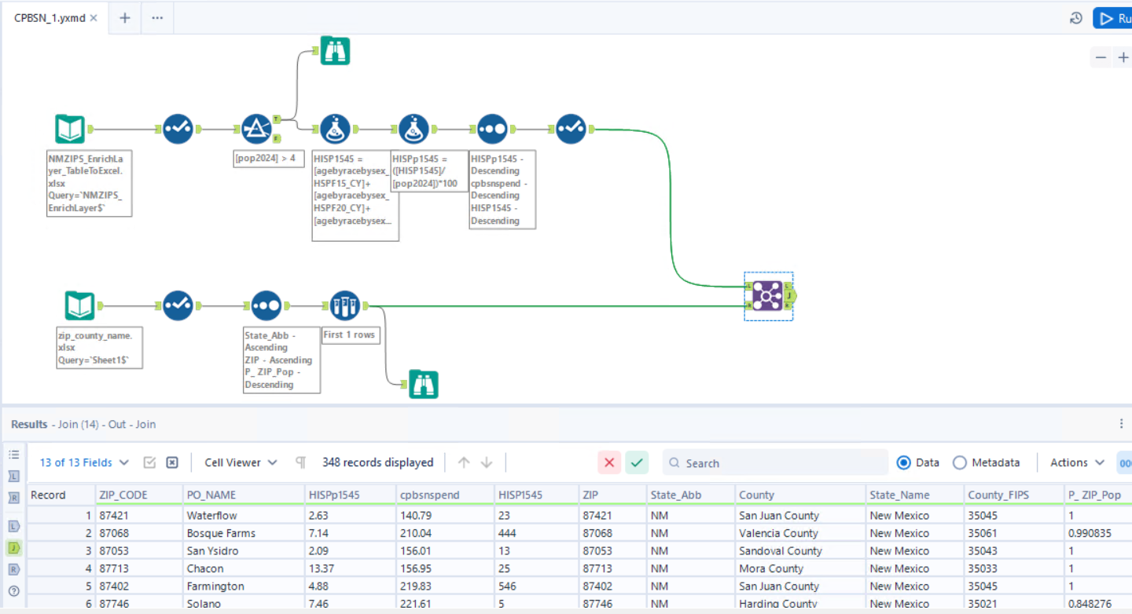

1. **Explain analyzes and interpret results:**

With these actions, I am creating a summary table of zip code results by county for my target state of New Mexico. First, I group my records (zip codes) by county, then I get the record (zip code) count within each county. Next, I calculate the average annual cosmetics/skincare spend per household by county, and the average percentage of Hispanic females aged 15–44 within each county, both averaged across the county’s zip codes. Then, I get the sum of Hispanic females aged 15–44 by county across all its zip codes. Finally, I include the county FIPS code, or government identifier, for each county, which I will use in the next part of my analysis.

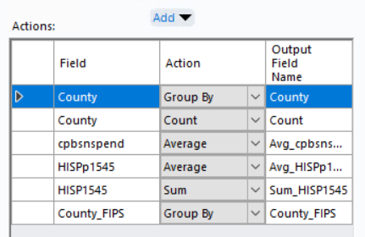

1. **Explain analyses and interpret results:**

I used a standard sort, sorting first on my primary variable: the percentage of the population in my user group of Hispanic females aged 15–44 (Avg_HISPp1545). Dona Ana County looks best as my first sort variable places it at the top, with 15.51% of its population in my user group, averaging across its 23 zip codes. Since there were no ties on this first sort variable, none of the other variables affected the sort—though their values (like average cosmetics/skincare spend and total population count) are still displayed and may support secondary insights.

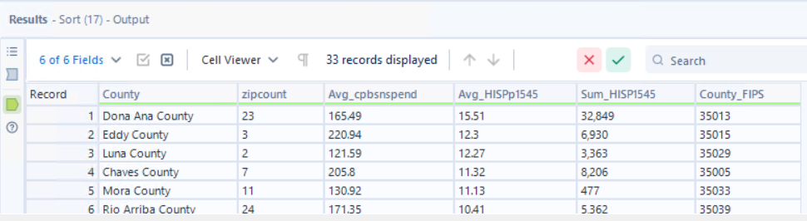

1. **Explain analyses and interpret results:**

I analyzed zip code data for my target state of New Mexico’s 33 counties (see record count). I averaged or summed the project data across all zip codes in each county to determine the best county to target. I then sorted the counties by the count of Hispanic females aged 15–44 (Sum_HISP1545), making this my primary selection variable since most counties have comparable total populations. My goal is to identify a county with a high count of my user group so I can eventually scale outreach beyond one service site.

Overall, Bernalillo County is my best option. It has 74,602 Hispanic females aged 15–44 (see Sum_HISP1545), and includes 22 zip codes (see zipcount). Additionally, 9.14% of the population falls within my user group (see Avg_HISPp1545), and the average annual spend on cosmetics/skincare per household is $241.53 (see Avg_cpbsnspend), making it a strong candidate for targeted outreach. The County FIPS for Bernalillo is 35001, which I will use in the next stage of my analysis. Dona Ana County ranks second, with 32,849 target group members and a notably high average population share (15.51%), making it another strong option.

